Changes to US Space Cover Collecting Handbook for SU Website.

I inadvertently show Dr. Reuben A. Ramkissoon’s middle initial in four places in my handbook as“R”. The first is on the book’s cover, which is also the first page of the printed handbook. The other two are on page 3. Also, for the record, the spelling of his last name at the top of page 181 has a typo, leaving out an “o” from his last name.

On Dr. Ramkissoon’s biography on page 3, his exhibit title and awards won were, “The Development of the United States Lunar Exploration” which received several national and F.I.P. International Gold Awards.

Show GT-Capt. Covers pages, which was inserted to new handbooks showing :2nd Printing May 2011 at the lower right corner of page 2. The second printing has this inserted between Pgs 118 and 119.

Page 3 Change page number for VIP Cards from Pg 183 to Page 173 following KSC etc. Officials on pg. 165

Page 6. Add a footnote to the first paragraph: FIP has now changed the text to read, “a nearby post office”.
This was decided at the FIP Meeting in Lisbon, Portugal after this problem was pointed out to them.

Page 7 Add this to the bottom of the page. Note: Despite dozens of U.S. Judges critiques, which almost exclusively reflect individual judge’s opinions on the “Presentation” of exhibits, rarely touching upon content or individual knowledge and research, a critique of this handbook at NAPEX included this observation:
“Judges and Astrophilately have been at odds for a long time concerning astrophilatelists thinking that they had to use 'souvenir covers' to tell the story”.
This is not reflected in the Manual of Philatelic Judging for Astrophilately from which judging is based. Flown to the Moon covers are “Souvenir Covers”. Captain’s Covers are Souvenir Covers. Most Swanson, Rank, Sarzin, Goldey etc. covers are Souvenir covers.

During editing, the footnotes all either changed or disappeared. Here are the salvageable changes to footnotes.

Page 9. Change footnote number 17 to #2.

Page 12. Change footnotes number 18 and 19 to #3 and #4 respectively

Page 13. Change footnote 20 to #5

Page 14. Change footnote 10 to #6

Page 22 shows various types of covers flown on Regulus I and Regulus II missiles. Add to these the following:
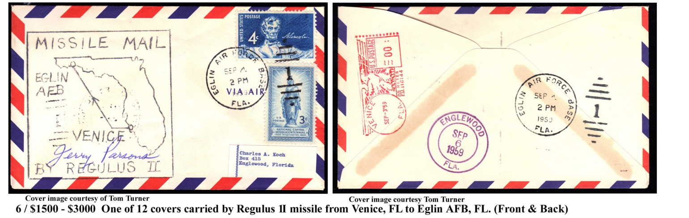

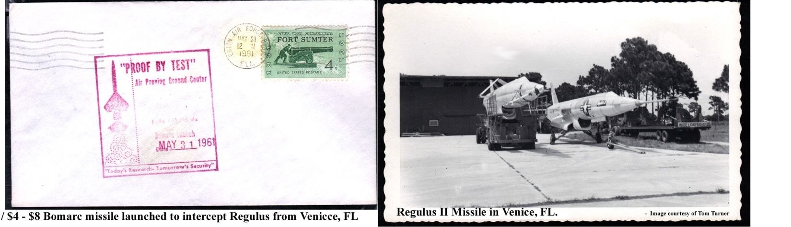

Page 26. Change footnote 11 to #7

Page 33. Change footnote 12 to #8

Page 36. Change footnote 13 to #9

Page 38. Change footnote 21 to #10 Also from “NASA Sounding Rocket Site” to “NASA on-line Sounding Rocket Site”.

Page 39. Change footnote 22 to #11

Page 42. Change footnote 23 to #12

Page 44. Change footnote 1 to #13. Add page number

Page 45 Change footnote 2 to #14

Page 49 Change footnote 19 to #15

Page 50 Change footnote 20 to #16

Page 52 Change footnote 21 to #17

Page 87 Change footnote 1 to #18

Page 108 Add under images of Captain’s Covers: NOTE: Collector Jane Beville noted a GT-7 Captain’s Cover with the latitude and longitude of the GT-6 recovery. Estimated 6 / $90 - $150 value on these.

Page 179 Change footnote 2 to #19

